Thin Lenses
Equipment Needed:

Lens, +100mm, Pasco
Lens, -150mm, Pasco
Light Source, Pasco OS-8517
AC Power Supply, Pasco Light Source Condor D12-10
Viewing Screen, w/2 binder clips PascoOS-8460

Multi-Clamp, Pasco ME-9507
Ring Stand Base, 0.5in
Ring Stand Rod, 0.5in x 60cm
Optics Track, Pasco OS-8508
Rod, Insulated w/ Metallic End

Figure 1 Equipment Used
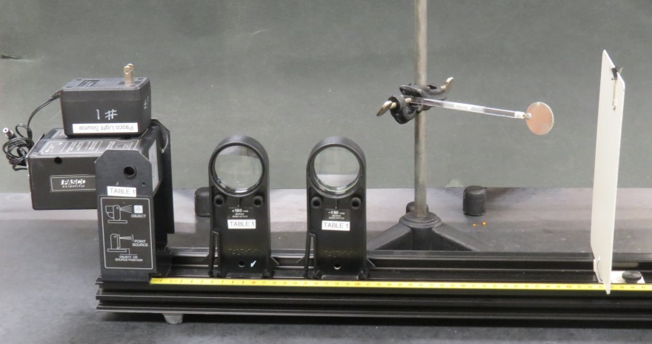
Introduction
Many optical instruments rely entirely on combinations of converging and diverging lenses. These lenses separately can create a wide variety of image types, sizes, and orientations. In combination, they create an even wider and more useful variety of images. Refracting telescopes and microscopes are examples of instruments relying on these types of lenses.
In this lab we will explore image formation using a converging lens and a diverging lens. In order to study the image formation of the diverging lens we will have to use the parallax method to find the image because it is virtual.
In optics a thin lens is a lens with a thickness (distance along the optical axis between the two surfaces of the lens) that is negligible compared to the radii of curvature of the lens surfaces.
In this lab we will work and measure examples of image formation as predicted by the thin lens formula,
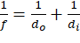
where,
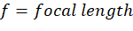
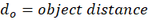
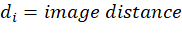
Procedure
Part I. Converging Lens
Figure 2 Setup for Converging Lens
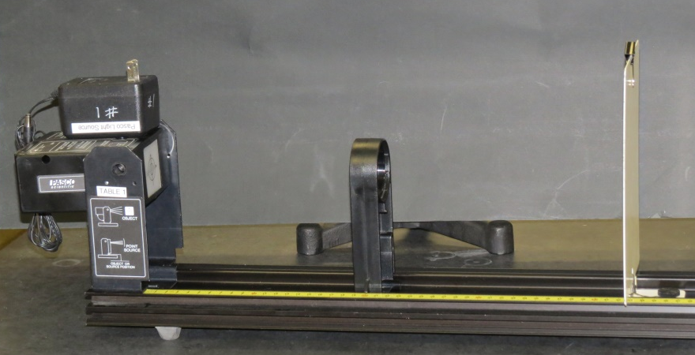
- Setup will look like Figure 2.
- For object distance of 30.0cm
  - Find the image distance. Record in Table 1.
  - Calculate the focal length. Record in Table 1.
  - Measure the relative size of the image compared to the object. Record in Table 1. Magnified (M) or diminished (D) by X amount.
  - Record the orientation of the image compared to the object. Record in Table 1. Upright (U) or inverted (I).
- Repeat 1a, 1b, 1c, and 1d for 20.0cm, 16.0cm, 14.0cm. Record in Table 1.

Part II. Diverging Lens.
Figure 3 Setup for Diverging Lens
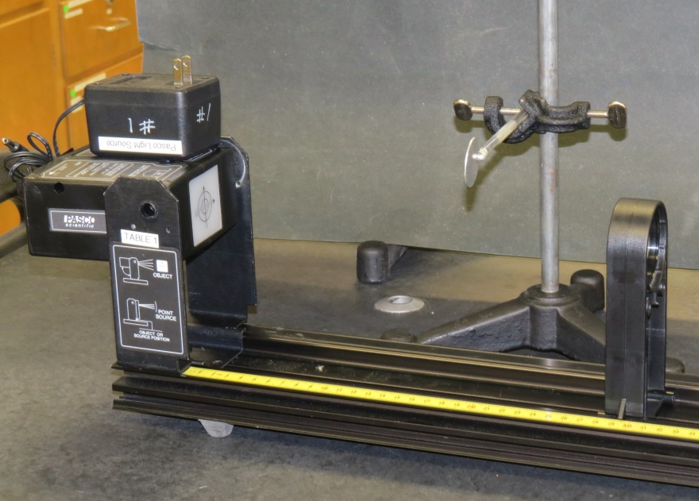
- Setup will look like Figure 3.
- Calculate for the distances 10cm, 20cm, and 30cm and enter into Table 2.
- Look into the lens directly toward the light source. You will be able to see the image. It should look like Figure 4.
Figure 4 Looking for
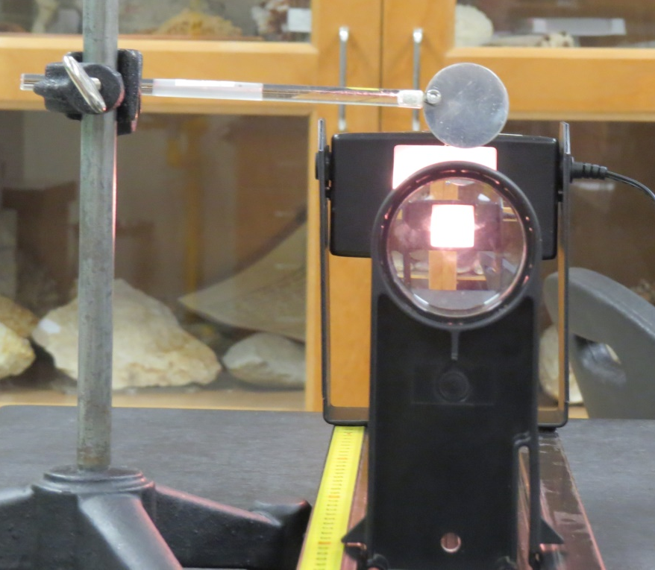
- Using both eyes, try to move the disk back and forth so that it is visually at the same point as the image. (This can be difficult to do. Sometimes closing one eye and then the other helps.)
- Record this in Table 2 under .

Table 1 Converging Lens
 |  |  | Orientation | Relative Size  (Magnification) |  | % err.
16cm |  |  |  |  | +100mm
18cm |  |  |  |  | +100mm
20cm |  |  |  |  | +100mm
25cm |  |  |  |  | +100mm
30cm |  |  |  |  | +100mm

Table 2 Diverging Lens
 |  |  | Orientation | Relative Size  (Magnification) |  | % err.
-150mm | 10cm
-150mm | 20cm
-150mm | 30cm

Questions
- Look at the percent error in Table 1. Describe it. Why do you think it trends in this manner?

- Were there any orientations where no image was formed? Why or why not? Explain.
- A lens with focal length of 2.0 cm is placed close to a lens with focal length of -6.0 cm. This combination is taken outdoors on a sunny day. How many centimeters from the lens should a piece of paper be held so that a sharp image forms on it?

